**Project Design Phase-II**

**Data Flow Diagram & User Stories**

|  |  |
| --- | --- |
| Date | 16 April 2025 |
| Team ID | SWTID1744825374 |
| Project Name | SB Foods – MERN Stack Food Ordering Web App |
| Maximum Marks | 4 Marks |

**Data Flow Diagrams:**

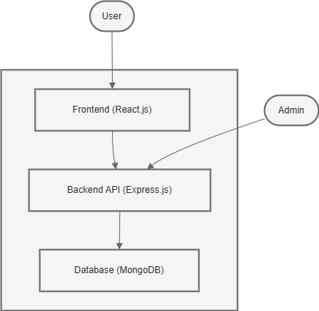

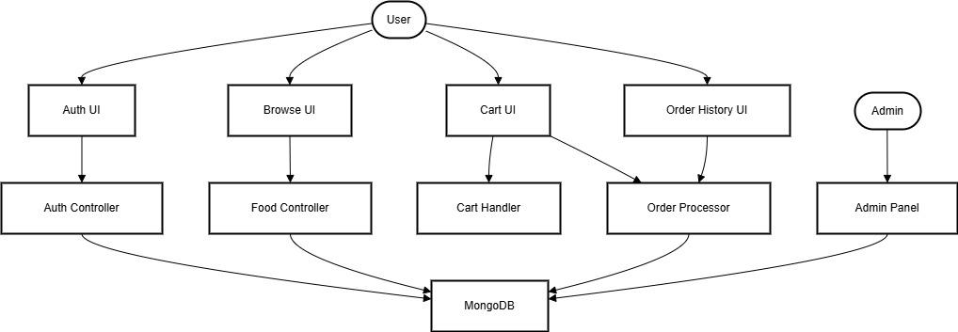

**User Stories**

|  |  |  |  |  |  |  |
| --- | --- | --- | --- | --- | --- | --- |
| **User Type** | **Functional Requirement (Epic)** | **User Story Number** | **User Story / Task** | **Acceptance Criteria** | **Priority** | **Release** |
| Customer (Web) | Registration | USN-1 | As a user, I can register using email and password. | I can log in after registration. | High | Sprint-1 |
|  |  | USN-2 | As a user, I will receive confirmation once I register. | Confirmation is shown or email sent. | Medium | Sprint-1 |
|  | Login | USN-3 | As a user, I can log in with my email and password. | I can access the homepage if credentials are correct. | High | Sprint-1 |
|  | Browse Food | USN-4 | As a user, I can view available food by categories. | Food items are displayed with images and prices. | High | Sprint-1 |
|  | Add to Cart | USN-5 | As a user, I can add food items to my cart with quantity and size. | Items appear in cart with correct pricing. | High | Sprint-1 |
|  | Cart Management | USN-6 | As a user, I can view, modify, and remove items in my cart. | Cart reflects real-time changes. | High | Sprint-2 |
|  | Checkout | USN-7 | As a user, I can place an order and get confirmation. | Order is saved and alert says “Payment Successful”. | High | Sprint-2 |
|  | Order History | USN-8 | As a user, I can view my past orders. | My orders appear sorted by date. | Medium | Sprint-3 |
| Administrator | Admin Control Panel (optional) | USN-9 | As an admin, I can add/edit/remove food items. | Admin changes reflect in the food listing. | Medium | Sprint-3 |